Project 2

Title
Battleship!

CIS 17A-47465
Tyler Purba
December 21st 2025

C++ Implementation of the Battleship Game
- Introduction
Battleship is a classic strategy board game that has been around for decades. Most people know it as a logic-based guessing game, although, if I’m being honest, I didn’t think there was much “strategy” involved until I played it in high school. Then I realized something very important:
it’s really just a guessing game, and everyone is pretending otherwise :)
Still Battleship feels strategic, and it balances logic, intuition, and prediction in a way that makes it a perfect candidate for a programming project. I chose it because it naturally requires many of the concepts we’ve learned in CIS-17A: dynamic arrays, structures, pointers, functions, and even binary file handling. This project wasn’t just another coding exercise like the usual, it allowed me to actually build a fully working game from scratch.
The rules are simple and well-documented, the game has existed far longer than I have, and almost everyone recognizes the idea: place ships, guess coordinates, and try not to get obliterated. Simple in theory and surprisingly very complicated in code.

2. Summary

2.1 Project Size and Line Count

The final version of this project ended with 1071 lines of code, exceeding the minimum requirement of 1000 lines. This increase from Project 1 reflects the transition from a primarily procedural design to a fully object-oriented implementation.

The additional lines come from splitting the program into multiple header and implementation files, adding class definitions, constructors, destructors, inheritance hierarchies, operator overloading, templates, exception handling, and documentation comments. While the gameplay and output remain the same as Project 1, the internal structure of the program is significantly more complex and better organized.

2.2 Variables and Constructs Used

I used a wide range of variables, data structures, and programming constructs, including:
- Multiple classes (Ship, Stat, Plyr, Hmn, Hm2, Game)
- Inheritance and polymorphism using a base Plyr class and derived player classes
- Abstract base classes with pure virtual functions
- Protected data members for controlled access in derived classes
- Dynamic 2D arrays for fleet and shot boards
- Dynamic arrays of objects for each player’s fleet
- Pointers and references, including polymorphic base-class pointers
- Templates (generic array printing function)
- Operator overloading (<<, <, ==)
- Static class members
- Copy constructors
- Exception handling for file input
- Binary file I/O for persistent statistics
- C-strings and character arrays
- Standard strings
- Modular helper functions split across multiple source files

2.3 Time Spent & Challenges
This project took significantly longer than Project 1 (good thing my finals were early so I could do this nonstop all week!). While the gameplay itself did not change, restructuring the entire program to meet object-oriented requirements introduced many new challenges.
The most time-consuming aspects included:
- Splitting a large procedural program into multiple .h and .cpp files
- Deciding which responsibilities belonged in which classes
- Implementing inheritance and polymorphism without overcomplicating the design
- Managing dynamic memory safely across constructors and destructors
- Ensuring the refactored code behaved exactly the same as Project 1
- Adding required concepts (templates, exceptions, operator overloading) without forcing unnecessary features
- Generating UML diagrams using Doxygen and producing accurate flowcharts
A major challenge was resisting the urge to over-engineer the solution. The goal was to demonstrate understanding of object-oriented programming concepts while keeping the code readable, explicit, and appropriate for this course.
Despite these challenges, the final result is a fully playable Battleship game that not only meets but exceeds the requirements for Project 2. The project demonstrates proper use of classes, inheritance, polymorphism, templates, dynamic memory management, file I/O, and documentation, while maintaining the same user experience as Project 1.

3. Description

3.1 Overview of Program Structure

To build the Battleship game for Project 2, the program was reorganized into multiple object-oriented systems, each responsible for a specific part of the game. While the gameplay and output remain the same as Project 1, the internal structure now relies on classes, inheritance, and modular design

1. Board System (Dynamic 2D Arrays)
Each player has two dynamic boards:
- A fleet board showing where their ships are placed
- A shot board showing their guesses against the opponent
These boards are created using dynamic 2D arrays (char**) allocated with new and cleaned up using delete[]. The boards store:
- '.' for empty
- 'S' for a ship
- 'X' for a hit
- 'O' for a miss
- Object-Oriented Game Data
The program is built using multiple classes, each with a clearly defined role:
- Ship
Stores ship-specific data such as name, size, hit count, orientation, and board position.
- Plyr (abstract base class)
Represents a generic player. It owns the fleet and shot boards, the fleet of ships, and declares a pure virtual turn() function.
- Hmn and Hm2 (derived classes)
Inherit from Plyr and implement the turn() function, demonstrating inheritance and polymorphism.
- Stat
Tracks player statistics including name, games played, and games won. Supports binary file I/O, operator overloading, static members, and copy construction.
- Game
Controls the flow of a full match. It aggregates two Plyr objects and manages ship placement, turn order, win detection, and stat updates.
This design separates responsibilities cleanly and allows the game loop to operate through base-class pointers, enabling polymorphic behavior.

3. Ship Placement System
Players manually enter ship positions during the setup phase.
The program:
- Converts coordinates (like "A10") into row/column values
- Validates ship placement
- Writes ship locations into the fleet board

4. Turn System / Shooting System
Each turn:
- The attacker views their fleet and shot boards
- The player inputs a target location (like "G7")
- The game checks whether the target is a hit or miss
- Boards are updated accordingly
- The game checks if a full ship is sunk
- The other player takes their turn
This continues until one player has all ships sunk.

5. Stats System (Binary File I/O)
After a game ends:
- The winner and loser stats are updated
- Updated stats are written into bstats.dat
- Stats persist between runs
- Users can view all past stats from the main menu
This demonstrates reading/writing raw structures from binary files.
3.2 Input/Output
Starting Menu:
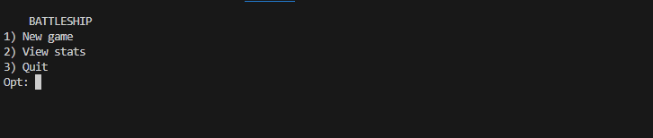
Player name enter
Input: 1
Player1
Player2
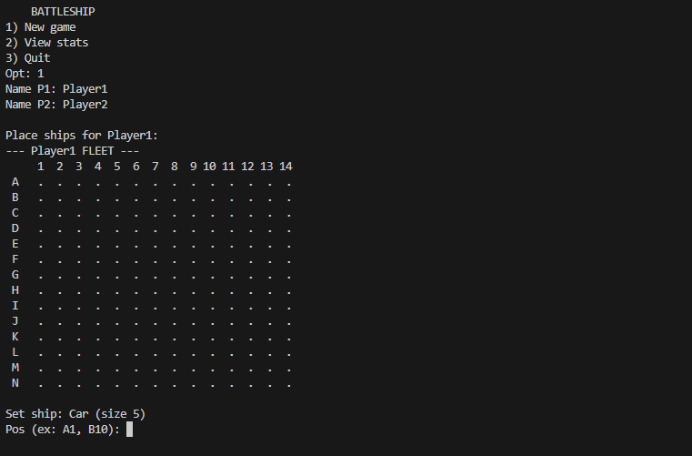
Setting up ships
Input: A1
V
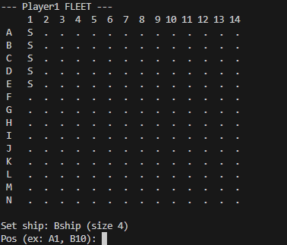
A3
H
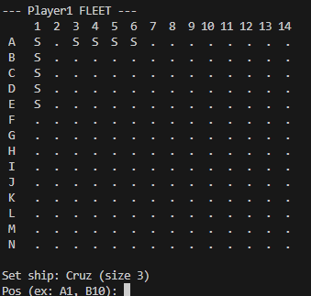
A1
V (again)
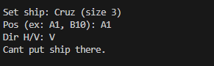
Choosing who goes first
Input: 50
72
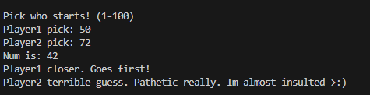
Taking a shot
Input: A1
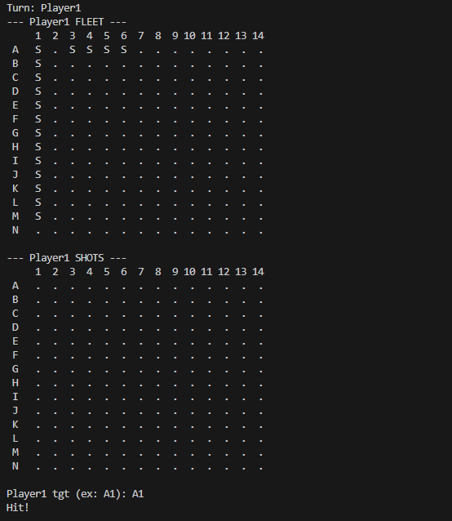
Missing a shot
Input: N14
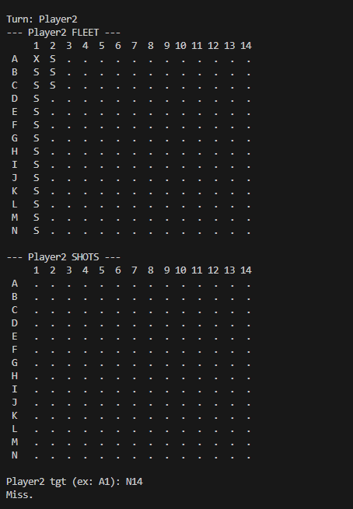
Endgame:
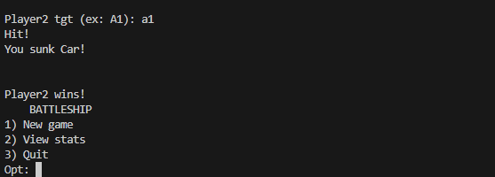
Viewing Stats
Input: 2
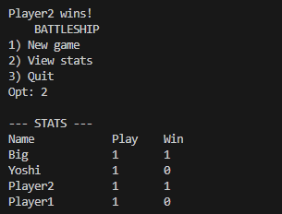

4.1 Flowcharts / Pseudocode
4.2 Flowchart
Flowchart 1 -Main Program and Menu
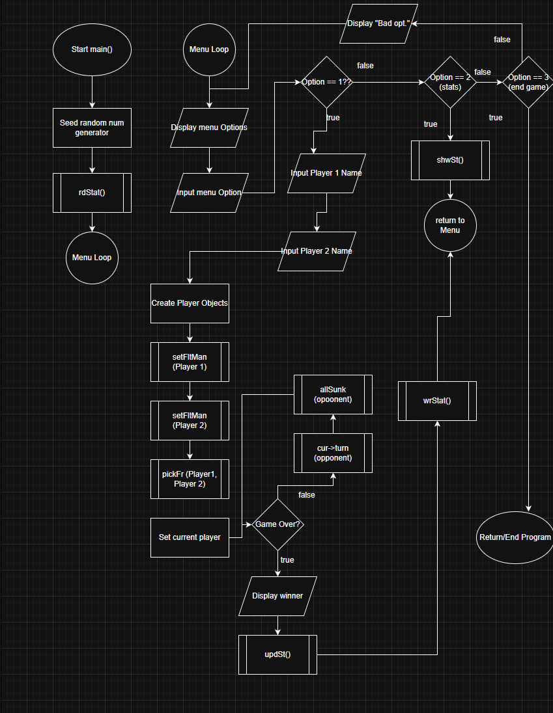
4.3 Pseudocode
Main Program
Start program
Load stats from binary file

Loop menu:
Display options: New Game, View Stats, Quit
If New Game → startMatch()
If View Stats → show stats table
If Quit → exit loop
Save stats on exit
End program

startMatch()
Prompt for player names
Initialize both player structs
Allocate boards and fleets

Each player places ships manually

Run choose-first-number game
Set currentPlayer = winner

While game not over:
currentPlayer fires shot
Mark hit or miss
If a ship is sunk → announce
If all ships sunk → winner declared
Switch turns
Update stats and write to file
Deallocate memory

Ship Placement:
For each ship:
Show board
Ask for position and direction
Validate position
If valid → place ship on board
Else → retry

Firing a Shot:
Ask player for coordinate
Validate input and ensure not already used

If coordinate hits a ship:
Mark hit on both boards
Increment ship's hit counter
If hits == size → ship is sunk

Else:
Mark miss

Stats System:
Read stats from binary file at start
On game end:
Find player entry or create one
Increment play counter
If player won → increment win
Write updated stats back to binary file

5. Variables

5.1 Major Classes
These are the main classes used by the program to represent ships, players, game flow, and persistent statistics.

Class Ship
Type | Name | Description | Location
char | name[8] | Short ship name (e.g. "Car", "Bship") used in messages | Class Ship
int | size | Length of the ship in board cells | Class Ship
int | hits | Number of times this ship has been hit | Class Ship
bool | sunk | True if the ship has been sunk | Class Ship
int | row | Starting row index (0–ROWS−1) | Class Ship
int | col | Starting column index (0–COLS−1) | Class Ship
char | dir | Direction: 'H' horizontal or 'V' vertical | Class Ship

Class Plyr (Abstract Base Class)
Type | Name | Description | Location
char | name[16] | Player name stored as a C-string | Class Plyr
char** | fb | Fleet board (dynamic 2D array) | Protected member
char** | sb | Shot board (dynamic 2D array) | Protected member
Ship* | flt | Dynamic array of ships | Protected member
int | snum | Number of ships in fleet (SNUM) | Protected member
Plyr is an abstract base class and cannot be instantiated directly. It defines shared data and a pure virtual turn() function.

Classes Hmn and Hm2 (Derived Player Classes)
These classes inherit from Plyr and implement the turn() function. They represent two human players and demonstrate inheritance and polymorphism.

Class Game
Type | Name | Description | Location
Plyr* | p1 | Pointer to player 1 | Class Game
Plyr* | p2 | Pointer to player 2 | Class Game
The Game class controls the full match, including ship placement, turn order, win detection, and stat updates. It demonstrates aggregation (a Game has two players).

Class Stat (Persistent Statistics)
Type | Name | Description | Location
char | nm[16] | Player name associated with stats | Class Stat
int | pl | Number of games played | Class Stat
int | wn | Number of games won | Class Stat
static int | cnt | Count of Stat objects created | Class Stat
This class supports binary file I/O, operator overloading, static members, and copy construction.

5.2 Global Constants
These constants control board size, fleet size, and statistics settings.
Type | Name | Value | Description
const int | ROWS | 14 | Number of board rows (A–N)
const int | COLS | 14 | Number of board columns (1–14)
const int | SNUM | 5 | Number of ships per player
const int | MS | 20 | Maximum number of stats records
const char[] | SFIL | "bstats.dat" | Binary stats file name
Using constants avoids magic numbers and allows easy configuration changes.

5.3 Main Function Variables
Type | Name | Description
Stat | st[MS] | Array of statistics records
int | sn | Current number of valid stat entries
int | opt | Menu option chosen by the user
char | nm1[16] | Player 1 name input
char | nm2[16] | Player 2 name input
Game | g | Game controller object

5.4 Board and Input Variables (Key Local Variables)
Board / Position Variables
Type | Name | Description | Location
int | row | Row index (0–ROWS−1) | Placement / turn logic
int | col | Column index (0–COLS−1) | Placement / turn logic
int | idx | Index of ship hit | hitShip()
int | d1 | Distance from player 1 guess | pickFr()
int | d2 | Distance from player 2 guess | pickFr()
int | tgt | Random target number | pickFr()
String / Text Variables
Type | Name | Description
string | pos | Raw coordinate input (e.g. "A10")
string | ttl | Board title string
string | ttl1 | Fleet board title
string | ttl2 | Shot board title
string | cStr | Numeric substring of coordinate

5.5 Dynamic Memory Variables
Type | Name | Description | Location
char** | fb | Dynamic 2D fleet board | Plyr
char** | sb | Dynamic 2D shot board | Plyr
Ship* | flt | Dynamic array of ships | Plyr
These are allocated in the Plyr constructor using new and freed in the Plyr destructor using delete[], demonstrating proper dynamic memory management and RAII principles.
.

6. Concepts Used

Carried over from Project 1

Chapter 9 – Pointers & Dynamic Memory

Dynamic Memory Allocation (new/delete)
Used to build every game board:
p.fb = mkBrd(ROWS, COLS);
p.sb = mkBrd(ROWS, COLS);
p.flt = new Ship[p.snum];
Deleted at the end:
delBrd(p.fb, ROWS);
delete [] p.flt;

Pointers to Arrays
The 2D boards use char** pointers and pointer arithmetic is handled internally:
char **mkBrd(int row, int col);

Pointers Passed Into Functions
Every major game function accepts pointers or structures containing pointers:
- doShot(Plyr &atk, Plyr &def)
- setFltMan(Plyr &p)
- pickFr(Plyr &p1, Plyr &p2, Plyr *&cur, Plyr *&oth)

Pointers to Structures
Accessing structure members through pointers:
cur->name
oth->flt[i]

Returning Pointers
mkBrd returns a dynamically allocated pointer:
char **mkBrd(int row, int col);

Relationship Between Arrays and Pointers
brd[r][c] = 'S';

Chapter 10 – Characters, C-Strings, and the string Class

Character Arrays (C-Strings)
Player names and ship names use fixed-size char[] arrays:
char name[16];
char shipName[8];

C-String Functions (strcpy, strncpy, strcmp)
Used throughout:
strcpy(flt[0].name, "Car");
strncpy(p.name, nm, 15);
strcmp(st[i].name, nm) == 0

Character Case Conversion
Used when processing user input:
dir = toupper(dir);
char rCh = toupper(in[0]);

String Objects
Used for UI text and board titles:
string ttl = string(p.name) + " FLEET";

Mixing C-Strings and string

Chapter 11 – Structured Data (struct)

Multiple Structures Created
- Ship
- Plyr
- Stat
- Cpu (reserved for future CPU mode)

Arrays of Structures
Each player has:
Ship *flt // dynamic array of Ship

Structures as Function Arguments
void doShot(Plyr &atk, Plyr &def);
bool canPut(Plyr &p, Ship &s, int row, int col, char dir);

Structures Containing Pointers
Plyr contains pointers to:
- dynamic boards
- dynamic array of ships

Pointers to Structures
Used everywhere:
Plyr *cur = &p1;
cur->flt[i]

Chapter 12 – Files, Formatting, and Binary I/O

Binary File Reading/Writing
Stat structures are stored in bstats.dat using binary mode:
fin.read(reinterpret_cast<char*>(&st[n]), sizeof(Stat));
fout.write(reinterpret_cast<char*>(&st[i]), sizeof(Stat));

File Opening and Error Handling
ifstream fin(SFIL, ios::binary);
ofstream fout(SFIL, ios::binary);

Creating Records Using Structures
Each Stat entry is a serialized structure in the file.

Passing File Streams to Functions
Indirectly shown by placing file logic inside helper functions (rdStat, wrStat).
Introduced in Project 2:

Chapter 13 – Classes
Instances of a Class (1–3)
Multiple class instances are created throughout the program, including Ship, Stat, Hmn, Hm2, and Game objects. These are instantiated both on the stack and dynamically where appropriate.
Private Data Members (4)
Classes such as Stat use private data members to enforce encapsulation. Data is accessed only through public getter and setter functions.
Specification vs. Implementation (5)
All major classes are split into header (.h) and implementation (.cpp) files. Class interfaces are declared in headers, while logic is implemented in source files.
Inline Functions (6)
Simple accessor functions (such as getters) are defined inline in headers where appropriate.
Constructors and Overloading (7, 8, 10)
Classes implement multiple constructors, including default and parameterized constructors. Overloaded constructors are used in Ship, Plyr, Hmn, Hm2, and Stat.
Arrays of Objects (12)
Arrays of class objects are used, such as the array of Stat objects that stores persistent statistics records.
UML (16)
UML diagrams were generated using Doxygen to visualize class relationships, inheritance, and aggregation.

Chapter 14 – More About Classes
Static Members (1)
The Stat class contains a static member used to count how many Stat objects have been created, demonstrating class-wide shared data.
Friend Functions (2)
The stream insertion operator (operator<<) is implemented as a friend function of the Stat class to allow formatted output while keeping data members private.
Copy Constructors (4)
The Stat class includes an explicit copy constructor, demonstrating proper copying of class data.
Operator Overloading (5)
Multiple operators are overloaded for the Stat class, including:
- operator<< for output
- operator< for comparisons
- operator== for equality checks
Aggregation (7)
The Game class aggregates two Plyr objects. A game “has” players but does not own their lifetime, demonstrating aggregation rather than composition.

Chapter 15 – Inheritance
Protected Members (1)
The Plyr base class uses protected members so derived classes can access shared data such as boards and fleets.
Base Class to Derived Classes (2–5)
Hmn and Hm2 inherit from the abstract base class Plyr, sharing common functionality while implementing their own behavior.
Polymorphic Associations (6)
The game operates on base-class pointers (Plyr*) while calling overridden methods, allowing runtime polymorphism.
Abstract Classes (7)
Plyr is an abstract class containing a pure virtual turn() function, enforcing that derived classes must implement turn behavior.

Chapter 16 – Advanced Classes
Exceptions (1)
Exceptions are used when loading the statistics file. If the binary file does not exist, the program safely handles the error and creates a new stats file.
Templates (2–4)
A function template is included to demonstrate generic programming, allowing arrays of different types to be printed using the same function.
STL (5)
Standard Library components such as std::string, std::ifstream, std::ofstream, and formatted output utilities are used appropriately without over-reliance on advanced containers.

- References
Textbook
cplusplus.com (references to clarify function behavior)
battleshiponline.org
Class Lectures
Stack Overflow (used to clarify syntax and C++ function and operator behavior)
Doxygen documentation

Program:
main.cpp:
/*
* File: main.cpp
* Author: Tyler Purba
*
* Proj: Battleship Game
*
*/

#include <iostream>
#include <iomanip>
#include <cstdlib>
#include <ctime>
#include <fstream>
#include <string>
#include <cctype>
#include <cstring>
#include <stdexcept>

#include "Ship.h"
#include "Stat.h"
#include "Plyr.h"
#include "brd.h"
#include "stfunc.h"
#include "plfunc.h"
#include "cfg.h"
#include "Hmn.h"
#include "Hm2.h"
#include "Game.h"

using namespace std;

// template example (prints any array type that supports <<)
template <class T>
void prtArr(T arr[], int sz) {
for (int i = 0; i < sz; i++) {
cout << arr[i] << endl;
}
}

const int MS = 20; // max stats records

int main(int argc, char** argv) {
// seed randomness for start picker (and any other random parts)
srand(static_cast<unsigned int>(time(0)));

Stat st[MS];
int sn = 0;

// exception example: stats file may not exist on first run
try {
sn = rdStat(st, MS);
}
catch (const exception &e) {
sn = 0;
cout << "No stat file yet. New file will be made." << endl;
}

int opt = 0;
while (true) {
cout << " BATTLESHIP " << endl;
cout << "1) New game" << endl;
cout << "2) View stats" << endl;
cout << "3) Quit" << endl;
cout << "Opt: ";
cin >> opt;

if (cin.fail()) {
cin.clear(); // clear fail flag
cin.ignore(10000, '\n'); // drop bad input
cout << "Bad opt." << endl;
continue; // restart menu loop
}

if (opt == 1) {
char nm1[16], nm2[16];

cout << "Name P1: ";
cin >> setw(16) >> nm1;

cout << "Name P2: ";
cin >> setw(16) >> nm2;

// player objects (derived from Plyr)
Hmn p1(nm1);
Hm2 p2(nm2);

// aggregation: Game "has" two players
Game g(&p1, &p2);
g.run(st, sn, MS);
}
else if (opt == 2) {
shwSt(st, sn);
}
else if (opt == 3) {
break;
}
else {
cout << "Bad opt." << endl;
}
}

return 0;
}

brd.cpp:
#include "brd.h"
#include <iostream>

using namespace std;

// allocate a dynamic 2D board (row pointers + column arrays)
char **mkBrd(int row, int col) {
char **brd = new char*[row];
for (int r = 0; r < row; r++) {
brd[r] = new char[col];
}
return brd;
}

// free memory allocated by mkBrd
void delBrd(char **brd, int row) {
for (int r = 0; r < row; r++) {
delete [] brd[r];
}
delete [] brd;
}

// fill entire board with a single character
void clrBrd(char **brd, int row, int col, char ch) {
for (int r = 0; r < row; r++) {
for (int c = 0; c < col; c++) {
brd[r][c] = ch;
}
}
}

// print board with row/column labels
void prtBrd(char **brd, int row, int col, const string &ttl) {
cout << "--- " << ttl << " ---" << endl;

cout << " ";
for (int c = 0; c < col; c++) {
if (c + 1 < 10) {
cout << " " << c + 1 << " ";
} else {
cout << c + 1 << " ";
}
}
cout << endl;

for (int r = 0; r < row; r++) {
char rLab = 'A' + r;
cout << " " << rLab << " ";
for (int c = 0; c < col; c++) {
cout << " " << brd[r][c] << " ";
}
cout << endl;
}
cout << endl;
}

brd.h:
#ifndef BRD_H
#define BRD_H

#include <string>

/*
* Board helper functions.
* Used for creating, clearing, and displaying the game boards.
*/

// allocate a dynamic 2D board (row x col)
char **mkBrd(int row, int col);

// free a dynamic 2D board
void delBrd(char **brd, int row);

// fill board with a single character (ex: '.')
void clrBrd(char **brd, int row, int col, char ch);

// print board with title and row/column labels
void prtBrd(char **brd, int row, int col, const std::string &ttl);

#endif

cfg.h:
#ifndef CFG_H
#define CFG_H

const int ROWS = 14; // A-N
const int COLS = 14; // 1-14
const int SNUM = 5; // ships

#endif

Game.cpp:
#include "Game.h"
#include "plfunc.h"
#include "stfunc.h"
#include <iostream>

using namespace std;

Game::Game(Plyr *a, Plyr *b) {
// store player pointers (players owned outside Game)
p1 = a;
p2 = b;
}

void Game::run(Stat st[], int &sn, int max) {
// fleet setup
cout << endl << "Place ships for " << p1->name << ":" << endl;
setFltMan(*p1);

cout << endl << "Place ships for " << p2->name << ":" << endl;
setFltMan(*p2);

// decide who goes first
Plyr *cur = p1;
Plyr *oth = p2;
pickFr(*p1, *p2, cur, oth);

// main turn loop
while (true) {
cout << endl << "Turn: " << cur->name << endl;
cur->turn(*oth); // polymorphism: calls correct derived turn()

if (allSunk(*oth)) {
cout << endl << cur->name << " wins!" << endl;

// update stats and save
updSt(st, sn, max, cur->name, true);
updSt(st, sn, max, oth->name, false);

wrStat(st, sn);
break;
}

// swap players
Plyr *tmp = cur;
cur = oth;
oth = tmp;
}
}

Game.h:
#ifndef GAME_H
#define GAME_H

#include "Plyr.h"
#include "cfg.h"
#include "Stat.h"

/*
* Game class
* Controls one full Battleship match between two players.
* Demonstrates aggregation (Game has two Plyr objects).
*/
class Game {
private:
Plyr *p1; // player 1
Plyr *p2; // player 2

public:
Game(Plyr *a, Plyr *b); // store player pointers

// run a full game and update stats
void run(Stat st[], int &sn, int max);
};

#endif

Hm2.cpp
#include "Hm2.h"
#include "brd.h"
#include "cfg.h"
#include <iostream>
#include <string>

using namespace std;

// helpers implemented in plfunc.cpp
bool getPos(const string &in, int &row, int &col);
int hitShip(Plyr &def, int row, int col);

// second human player turn (same logic as Hmn)
void Hm2::turn(Plyr &def) {
string ttl1 = string(name) + " FLEET";
string ttl2 = string(name) + " SHOTS";

// display boards
prtBrd(fb, ROWS, COLS, ttl1);
prtBrd(sb, ROWS, COLS, ttl2);

int row, col;
string pos;

// get valid target
while (true) {
cout << name << " tgt (ex: A1): ";
cin >> pos;

if (!getPos(pos, row, col)) {
cout << "Bad pos. Try agn." << endl;
continue;
}
if (sb[row][col] != '.') {
cout << "Used pos. Pick new." << endl;
continue;
}
break;
}

// apply hit or miss
if (def.getFb()[row][col] == 'S') {
cout << "Hit!" << endl;
def.getFb()[row][col] = 'X';
sb[row][col] = 'X';

int idx = hitShip(def, row, col);
if (idx != -1) {
Ship &s = def.getFlt()[idx];
s.hits++;
if (s.hits >= s.size && !s.sunk) {
s.sunk = true;
cout << "You sunk " << s.name << "!" << endl;
}
}
} else if (def.getFb()[row][col] == '.') {
cout << "Miss." << endl;
def.getFb()[row][col] = 'O';
sb[row][col] = 'O';
} else {
cout << "Weird pos, already hit." << endl;
}

cout << endl;
}

// constructors forward to base class
Hm2::Hm2() : Plyr() {}
Hm2::Hm2(const char nm[]) : Plyr(nm) {}

Hm2.h
#ifndef HM2_H
#define HM2_H

#include "Plyr.h"

/*
* Human player class. (2!)
* Implements turn logic using user input.
*/
class Hm2 : public Plyr {
public:
Hm2(); // default ctor
Hm2(const char nm[]); // ctor with player name

// override of base class turn function
void turn(Plyr &def) override;
};

#endif

Hmn.cpp
#include "Hmn.h"
#include "brd.h"
#include "cfg.h"
#include <iostream>
#include <string>

using namespace std;

// helpers implemented in plfunc.cpp
bool getPos(const string &in, int &row, int &col);
int hitShip(Plyr &def, int row, int col);

// human player turn: prompt user and process shot
void Hmn::turn(Plyr &def) {
string ttl1 = string(name) + " FLEET";
string ttl2 = string(name) + " SHOTS";

// show current boards
prtBrd(fb, ROWS, COLS, ttl1);
prtBrd(sb, ROWS, COLS, ttl2);

int row, col;
string pos;

// get valid target position
while (true) {
cout << name << " tgt (ex: A1): ";
cin >> pos;

if (!getPos(pos, row, col)) {
cout << "Bad pos. Try agn." << endl;
continue;
}
if (sb[row][col] != '.') {
cout << "Used pos. Pick new." << endl;
continue;
}
break;
}

// process hit or miss
if (def.getFb()[row][col] == 'S') {
cout << "Hit!" << endl;
def.getFb()[row][col] = 'X';
sb[row][col] = 'X';

int idx = hitShip(def, row, col);
if (idx != -1) {
Ship &s = def.getFlt()[idx];
s.hits++;
if (s.hits >= s.size && !s.sunk) {
s.sunk = true;
cout << "You sunk " << s.name << "!" << endl;
}
}
} else if (def.getFb()[row][col] == '.') {
cout << "Miss." << endl;
def.getFb()[row][col] = 'O';
sb[row][col] = 'O';
} else {
cout << "Weird pos, already hit." << endl;
}

cout << endl;
}

// constructors just forward to base class
Hmn::Hmn() : Plyr() {}
Hmn::Hmn(const char nm[]) : Plyr(nm) {}

Hmn.h
#ifndef HMN_H
#define HMN_H

#include "Plyr.h"

/*
* Human player class.
* Implements turn logic using user input.
*/
class Hmn : public Plyr {
public:
Hmn(); // default ctor
Hmn(const char nm[]); // ctor with player name

// override of base class turn function
void turn(Plyr &def) override;
};

#endif
plfunc.cpp
#include "plfunc.h"
#include "brd.h"

#include <iostream>
#include <cctype>

using namespace std;

// simple 1-6 roll (used for random choices)
int dice() {
return rand() % 6 + 1; // 1-6
}

// create the 5 standard ships and reset their status
void mkFlt(Ship *flt, int snum) {
flt[0] = Ship("Car", 5);
flt[1] = Ship("Bship", 4);
flt[2] = Ship("Cruz", 3);
flt[3] = Ship("Sub", 3);
flt[4] = Ship("Dest", 2);

// clear ship state before placement
for (int i = 0; i < snum; i++) {
flt[i].hits = 0;
flt[i].sunk = false;
flt[i].row = 0;
flt[i].col = 0;
flt[i].dir = 'H';
}
}

// convert "A10" into row/col indexes
bool getPos(const string &in, int &row, int &col) {
if (in.size() < 2) return false;

char rCh = toupper(in[0]);
if (rCh < 'A' || rCh > 'A' + ROWS - 1) return false;

string cStr = in.substr(1);
int cNum = 0;

// build column number from digits (supports 1-14)
for (int i = 0; i < static_cast<int>(cStr.size()); i++) {
if (!isdigit(static_cast<unsigned char>(cStr[i]))) return false;
cNum = cNum * 10 + (cStr[i] - '0');
}

if (cNum < 1 || cNum > COLS) return false;

row = rCh - 'A';
col = cNum - 1;
return true;
}

// check if a ship fits on the board without overlap
bool canPut(Plyr &p, Ship &s, int row, int col, char dir) {
if (dir == 'H') {
if (col + s.size > COLS) return false;
for (int c = col; c < col + s.size; c++) {
if (p.fb[row][c] != '.') return false;
}
} else if (dir == 'V') {
if (row + s.size > ROWS) return false;
for (int r = row; r < row + s.size; r++) {
if (p.fb[r][col] != '.') return false;
}
} else {
return false;
}
return true;
}

// write ship cells onto the fleet board
void putShip(Plyr &p, Ship &s) {
int row = s.row;
int col = s.col;

if (s.dir == 'H') {
for (int c = col; c < col + s.size; c++) {
p.fb[row][c] = 'S';
}
} else {
for (int r = row; r < row + s.size; r++) {
p.fb[r][col] = 'S';
}
}
}

// manual placement: ask user for pos + direction for each ship
void setFltMan(Plyr &p) {
for (int i = 0; i < p.snum; i++) {
Ship &s = p.flt[i];

bool ok = false;
while (!ok) {
string ttl = string(p.name) + " FLEET";
prtBrd(p.fb, ROWS, COLS, ttl);

cout << "Set ship: " << s.name
<< " (size " << s.size << ")" << endl;
cout << "Pos (ex: A1, B10): ";
string pos;
cin >> pos;

int row, col;
if (!getPos(pos, row, col)) {
cout << "Bad pos. Try agn." << endl << endl;
continue;
}

cout << "Dir H/V: ";
char dir;
cin >> dir;
dir = toupper(dir);

if (!canPut(p, s, row, col, dir)) {
cout << "Cant put ship there." << endl << endl;
continue;
}

// store ship placement + draw on board
s.row = row;
s.col = col;
s.dir = dir;
putShip(p, s);
ok = true;
}
}

string ttl = string(p.name) + " FLEET DONE";
prtBrd(p.fb, ROWS, COLS, ttl);
}

// find which ship index is at a hit location
int hitShip(Plyr &def, int row, int col) {
for (int i = 0; i < def.snum; i++) {
Ship &s = def.flt[i];
int r = s.row;
int c = s.col;

if (s.dir == 'H') {
for (int k = 0; k < s.size; k++) {
if (r == row && (c + k) == col) {
return i;
}
}
} else { // 'V'
for (int k = 0; k < s.size; k++) {
if ((r + k) == row && c == col) {
return i;
}
}
}
}
return -1; // not found
}

// return true if every ship in the fleet is sunk
bool allSunk(Plyr &p) {
for (int i = 0; i < p.snum; i++) {
if (!p.flt[i].sunk) return false;
}
return true;
}

// simple "closest to random number" to decide who starts
void pickFr(Plyr &p1, Plyr &p2, Plyr *&cur, Plyr *&oth) {
const int MINN = 1;
const int MAXN = 100;

while (true) {
int g1, g2;

cout << endl << "Pick who starts! (" << MINN << "-" << MAXN << ")" << endl;

cout << p1.name << " pick: ";
cin >> g1;
while (g1 < MINN || g1 > MAXN) {
cout << "Pick " << MINN << "-" << MAXN << ": ";
cin >> g1;
}

cout << p2.name << " pick: ";
cin >> g2;
while (g2 < MINN || g2 > MAXN) {
cout << "Pick " << MINN << "-" << MAXN << ": ";
cin >> g2;
}

int tgt = rand() % (MAXN - MINN + 1) + MINN;
cout << "Num is: " << tgt << endl;

int d1 = g1 - tgt;
if (d1 < 0) d1 = -d1;
int d2 = g2 - tgt;
if (d2 < 0) d2 = -d2;

if (d1 < d2) {
cout << p1.name << " closer. Goes first!" << endl;
cout << p2.name << " terrible guess. Pathetic really. Im almost insulted >:)" << endl;
cur = &p1;
oth = &p2;
break;
} else if (d2 < d1) {
cout << p2.name << " closer. Goes first!" << endl;
cout << p1.name << " that was an awful guess. You deserve to lose :)" << endl;
cur = &p2;
oth = &p1;
break;
} else {
cout << "Tie. You both suck. Try again :)" << endl;
}
}
}

plfunc.h
#ifndef PLFUNC_H
#define PLFUNC_H

#include <string>
#include "cfg.h"
#include "Ship.h"
#include "Plyr.h"

/*
* Player-related helper functions.
* Handles turn logic, ship placement, and win conditions.
*/

// roll a die
int dice();

// check which ship was hit (returns index or -1)
int hitShip(Plyr &def, int row, int col);

// return true if all ships are sunk
bool allSunk(Plyr &p);

// initialize fleet array with ship types
void mkFlt(Ship *flt, int snum);

// ship placement helpers
bool canPut(Plyr &p, Ship &s, int row, int col, char dir);
void putShip(Plyr &p, Ship &s);

// manual fleet setup (player input)
void setFltMan(Plyr &p);

// convert input like "A10" into row/column indexes
bool getPos(const std::string &in, int &row, int &col);

// decide which player goes first
void pickFr(Plyr &p1, Plyr &p2, Plyr *&cur, Plyr *&oth);

#endif

Plyr.cpp
#include "Plyr.h"
#include "brd.h"
#include <cstring>

using namespace std;

// helper to initialize fleet array
void mkFlt(Ship *flt, int snum);

Plyr::Plyr() {
name[0] = '\0';
fb = nullptr;
sb = nullptr;
flt = nullptr;
snum = SNUM;
}

Plyr::Plyr(const char nm[]) {
// copy player name
strncpy(name, nm, 15);
name[15] = '\0';

snum = SNUM;

// allocate boards dynamically
fb = mkBrd(ROWS, COLS);
sb = mkBrd(ROWS, COLS);

// initialize boards to empty
clrBrd(fb, ROWS, COLS, '.');
clrBrd(sb, ROWS, COLS, '.');

// allocate and initialize fleet
flt = new Ship[snum];
mkFlt(flt, snum);
}

Plyr::~Plyr() {
// clean up all dynamically allocated memory
if (fb != nullptr) { delBrd(fb, ROWS); fb = nullptr; }
if (sb != nullptr) { delBrd(sb, ROWS); sb = nullptr; }
if (flt != nullptr) { delete [] flt; flt = nullptr; }
}

Plyr.h
#ifndef PLYR_H
#define PLYR_H

#include "cfg.h"
#include "Ship.h"

/*
* Plyr (Player) base class
* Shared data and behavior for all player types.
* Used to demonstrate inheritance and polymorphism.
*/
class Plyr {
public:
char name[16]; // player name

protected:
// protected so derived classes can access boards and ships
char **fb; // fleet board
char **sb; // shot board
Ship *flt; // fleet of ships
int snum; // number of ships
// allow helper functions to access protected boards/fleet
friend bool canPut(Plyr &p, Ship &s, int row, int col, char dir);
friend void putShip(Plyr &p, Ship &s);
friend void setFltMan(Plyr &p);

friend int hitShip(Plyr &def, int row, int col);
friend bool allSunk(Plyr &p);

public:
Plyr(); // default ctor
Plyr(const char nm[]); // ctor with name
virtual ~Plyr(); // virtual dtor for polymorphic cleanup

// pure virtual function forces derived classes to implement turn logic
virtual void turn(Plyr &def) = 0;
char **getFb() { return fb; }
char **getSb() { return sb; }
Ship *getFlt() { return flt; }
int getSn() const { return snum; }
};

#endif

Ship.cpp
#include "Ship.h"

// default constructor: empty ship (values set later)
Ship::Ship() {
name[0] = '\0';
size = 0;
hits = 0;
sunk = false;
row = 0;
col = 0;
dir = 'H';
}

// constructor with name and size
Ship::Ship(const char nm[], int sz) {
// copy name safely into fixed-size array
strncpy(name, nm, 7);
name[7] = '\0';

size = sz;
hits = 0;
sunk = false;
row = 0;
col = 0;
dir = 'H';
}

Ship.h
#ifndef SHIP_H
#define SHIP_H

#include <cstring> // strncpy

/*
* Ship class
* Represents a single ship in the Battleship game.
* Stores position, orientation, and hit state.
*/
class Ship {
public:
char name[8]; // ship name (fixed size for simplicity)
int size; // ship length
int hits; // number of hits taken
bool sunk; // true when ship is sunk
int row; // starting row on board
int col; // starting column on board
char dir; // orientation: 'H' or 'V'

Ship(); // default ctor
Ship(const char nm[], int sz); // ctor with name and size
};

#endif

Stat.cpp
#include "Stat.h"
using namespace std;

// static member initialization
int Stat::cnt = 0;

Stat::Stat() {
nm[0] = '\0';
pl = 0;
wn = 0;
cnt++; // track number of Stat objects created
}

Stat::Stat(const Stat &o) {
// copy all data from source object
strncpy(nm, o.nm, 15);
nm[15] = '\0';
pl = o.pl;
wn = o.wn;
cnt++;
}

int Stat::getCnt() {
return cnt;
}

void Stat::setNm(const char n[]) {
strncpy(nm, n, 15);
nm[15] = '\0';
}

const char *Stat::getNm() const {
return nm;
}

void Stat::addPl() {
pl++; // increment games played
}

void Stat::addWn() {
wn++; // increment games won
}

int Stat::getPl() const {
return pl;
}

int Stat::getWn() const {
return wn;
}

void Stat::rdBin(std::ifstream &fin) {
// read fixed-size binary record
fin.read(nm, 16);
fin.read(reinterpret_cast<char*>(&pl), sizeof(pl));
fin.read(reinterpret_cast<char*>(&wn), sizeof(wn));
nm[15] = '\0';
}

void Stat::wrBin(std::ofstream &fout) const {
// write fixed-size binary record
fout.write(nm, 16);
fout.write(reinterpret_cast<const char*>(&pl), sizeof(pl));
fout.write(reinterpret_cast<const char*>(&wn), sizeof(wn));
}

std::ostream &operator<<(std::ostream &out, const Stat &s) {
// formatted output for stats display
out << std::left << std::setw(16) << s.getNm()
<< std::setw(8) << s.getPl()
<< std::setw(8) << s.getWn();
return out;
}

// comparison operators (not required for gameplay)
bool operator<(const Stat &a, const Stat &b) {
return a.getWn() < b.getWn();
}

bool operator==(const Stat &a, const Stat &b) {
return std::strcmp(a.getNm(), b.getNm()) == 0;
}

Stat.h
#ifndef STAT_H
#define STAT_H

#include <fstream>
#include <iomanip>
#include <cstring>
#include <ostream>

/*
* Stat class
* Stores win/loss information for a single player.
* Used for reading/writing stats to a binary file.
*/
class Stat {
private:
char nm[16]; // player name (fixed size for binary I/O)
int pl; // games played
int wn; // games won
static int cnt; // static count (for checkoff)

public:
Stat(); // default ctor
Stat(const Stat &o); // copy ctor
static int getCnt(); // return number of Stat objects created

void setNm(const char n[]);
const char *getNm() const;

void addPl(); // increment games played
void addWn(); // increment games won

int getPl() const;
int getWn() const;

// binary file helpers
void rdBin(std::ifstream &fin);
void wrBin(std::ofstream &fout) const;

// friend for operator<< (checks "friends" requirement)
friend std::ostream &operator<<(std::ostream &out, const Stat &s);
};

// operator overloads (defined in Stat.cpp)
std::ostream &operator<<(std::ostream &out, const Stat &s);

// comparison operators (used for sorting / comparisons if needed)
bool operator<(const Stat &a, const Stat &b);
bool operator==(const Stat &a, const Stat &b);

#endif

stfunc.cpp
#include "stfunc.h"
#include <iostream>
#include <iomanip>
#include <cstring>
#include <stdexcept>

using namespace std;

// stats binary file
const char SFIL[] = "bstats.dat";

int rdStat(Stat st[], int max) {
ifstream fin(SFIL, ios::binary);

// exception example: first run may not have a stats file yet
if (!fin) {
throw runtime_error("Stat file not found");
}

int n = 0;
while (n < max) {
// read name first to check EOF cleanly
char tmp[16];
fin.read(tmp, 16);
if (!fin) break;

// put cursor back so Stat can read the full record
fin.seekg(-16, ios::cur);
st[n].rdBin(fin);
n++;
}

fin.close();
return n;
}

void wrStat(Stat st[], int sn) {
ofstream fout(SFIL, ios::binary);
if (!fout) return; // can't save

for (int i = 0; i < sn; i++) {
st[i].wrBin(fout);
}
fout.close();
}

int findSt(Stat st[], int sn, const char nm[]) {
for (int i = 0; i < sn; i++) {
if (strcmp(st[i].getNm(), nm) == 0) {
return i;
}
}
return -1;
}

void updSt(Stat st[], int &sn, int max, const char nm[], bool win) {
int idx = findSt(st, sn, nm);

// new player: add record if there is room
if (idx == -1) {
if (sn >= max) return;
idx = sn;
sn++;

st[idx].setNm(nm);
}

st[idx].addPl();
if (win) st[idx].addWn();
}

void shwSt(Stat st[], int sn) {
cout << endl << "--- STATS ---" << endl;
if (sn == 0) {
cout << "No stat yet." << endl << endl;
return;
}

cout << left << setw(16) << "Name"
<< setw(8) << "Play"
<< setw(8) << "Win" << endl;

for (int i = 0; i < sn; i++) {
cout << st[i] << endl;
}
cout << endl;
}

stfunc.h
#ifndef STFUNC_H
#define STFUNC_H

/* Stats helper functions for Battleship.
*
* Handles reading/writing the binary stats file and printing stats.
* Uses the Stat class (name, games played, games won).
*/
#include "Stat.h"

// stats file name (defined in stfunc.cpp)
extern const char SFIL[];

/**
* @brief Read stats from the binary file into an array.
* @param st Array of Stat objects to fill.
* @param max Max number of records allowed in st.
* @return Number of records read.
*/
int rdStat(Stat st[], int max);

//Write stats array back to the binary file.
void wrStat(Stat st[], int sn);

//Find a stats record by name.
int findSt(Stat st[], int sn, const char nm[]);

//Update (or create) a player's stats record.
void updSt(Stat st[], int &sn, int max, const char nm[], bool win);

/**
* @brief Print stats to the console.
* @param st Array of Stat objects.
* @param sn Number of valid records.
*/
void shwSt(Stat st[], int sn);

#endif

